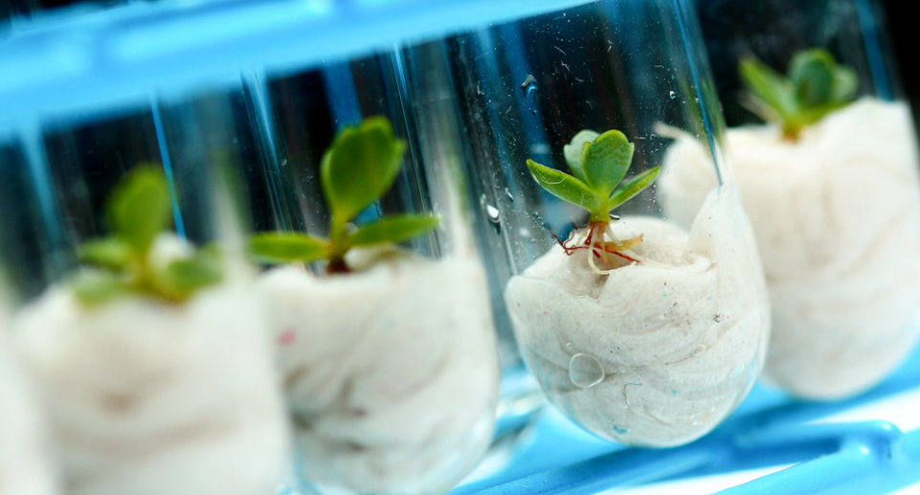
Business Finland, LIAA, Enterprise Estonia, Innovation Norway is organizing a 2-day event themed Circular Economy in the New Nordics – creating international growth through cooperation taking place on 24th and 25th of November 2020 online.
During this online event participants are offered insights into the future of circularity, ecosystem building-thinking and more practical opportunities for company-pitching and B2B-meetings aiming at forming possible future co-innovation partnerships. All participating countries have different expertise in the sectors of wood and textile and as such a joint platform for planning, forming and strengthening of cooperations is offered through this event.

AGENDA

TUESDAY 24TH OF NOVEMBER
13:30 Welcome
How to benefit from circular thinking
Keynote: Ecosystem collaboration and bringing circularity into the region - Kari Herlevi – Project Director, Circular Economy Sitra
Panel discussion: Circularity in the New Nordics
Moderator Gry K. Langbakk – Innovation adviser, Innovation Norway
Panelists:
Kerli Kvant Haas – Founder and CEO, Revualate
Cathrine Barth – Managing partner, Nordic Circular Hotspot
Dagnija Blumberga – RTU professor, Institute of Energy Systems and Environment, Latvia
Tim Forslund – Specialist, Circular economy, Sitra
Q&A, conclusions
Break
15:00 Creating added value through cooperation and ecosystem building
Moderator Ilmari Absetz, Program Director of Bio and Circular Economy, Business Finland
Aiming to design away the fossil-based society through an ecosystem of regional produce and know-how – Tone Berge, Architect MNAL, Bioregion Institute
Developing innovation Hub for High Value-Added Products from Local Biomass Resources – Roberts Rotbergs, Latvian Institute of Environmental Solutions
Collaboration and ecosystem building – Kaisa Hansen, New Entprepreneurship & Startup Center Manager, TalTech University
CLIC innovation: ecosystem building in energy, circular and bioeconomy – Jatta Jussila, CEO, CLIC Innovation
16:30 End of Day 1
WEDNESDAY 25.11.2020: BUSINESS NETWORKING DAY
09:00-10:00 Company pitching session
Sign up to present your company’s offering!
10:00-12:00 Panel discussions on value chains
10:00 Industrial wood construction value chains
Moderator Gatis Zamurs – Executive Director, Latvian Wood Construction Cluster
Margus Siilik – Founder, Okkastyle OÜ
Mikelis Putrams – Founder, Made Arhitekti
Kristine Nore – CEO, OmTRE AS
Juha Sojakka – CEO, Siparila
11:00 Circular textile value chains
Moderator Kerli Kvant Haas – Founder & CEO, Revaluate
Ragnhild Nordhagen – Designer & Product Developer, GU
Frode Svarstad – Quality Director, GU
Pernille Stolze –Textile designer, Flokk
Gatis Ginters – Head of Business development LSEZ, Liepaja
Reet Aus – Founding Partner, Upmade and Aus Design
Ali Harlin – Research Professor, VTT (Technical Research Center of Finland)
break
13:15-16:15 B2B meetings

